**EXPERIMENT 10 – TRIGGERS**

show databases;

use db;

show tables;

create table test(name varchar(2) primary key, marks int);

desc test;

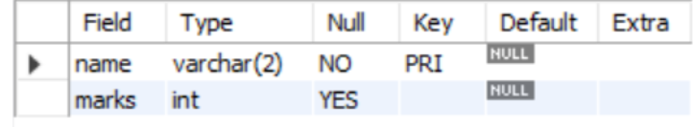

insert into test(name, marks) values("LS", 24);

insert into test(name, marks) values("CH",25);

insert into test(name, marks) values("RK",23);

select * from test;

create table test_audit(name varchar(2), marks int);

desc test_audit;

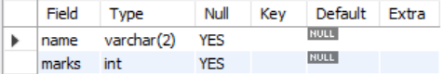

create trigger t

before insert on test

for each row

insert into test_audit set name = new.name,

marks = new.marks + 10;

insert into test values ("OP", 12);

show triggers;

select * from test;

update test set name = "AP" where name = "OP";

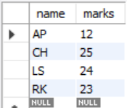

select * from test_audit;

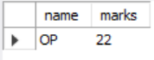

show triggers;

